Basic Bringup of PLL-Evalboard-Synthesizer

Rich Rademacher, University of Waterloo/IQC

January 2018

# Introduction

This document describes the bring up of our Phase-Locked Loop (PLL) frequency synthesizer for generating medium-precision RF carrier wave (CW) signals. The Quantum Ion Trap group at the Institute for Quantum Computing (IQC) uses a series of evaluation boards from Analog Devices and Perigrine Semiconductor to provide a low-cost series of RF drive signals.

# Initial Bring Up of ADF41020 Evaluation Board

The evaluation board is shown below:

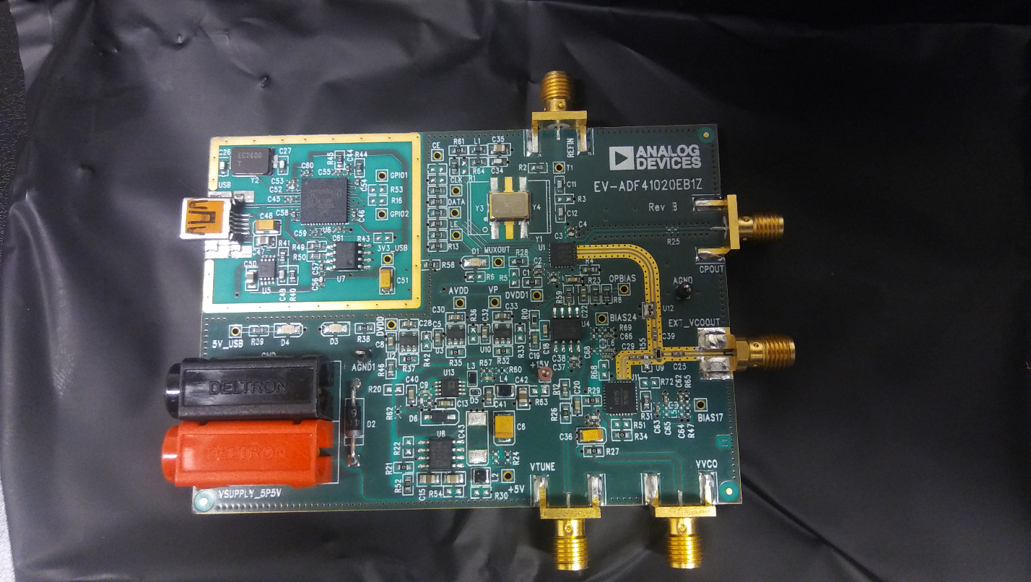

Figure 1 Microwave Synthesizer Showing Location of VCO

## Programming Software

The on-chip programming software from the ADI website is at <http://www.analog.com/media/en/evaluation-boards-kits/evaluation-software/ADI_Int-N.zip>. This software is required to operate the board without using the Raspberry Pi.

## Powering the EVB

An external power supply of +5.5V is required. USB power for communication is also required if not using the Raspberry Pi

# Initial Bring Up of ADF4355-2 Evaluation Board

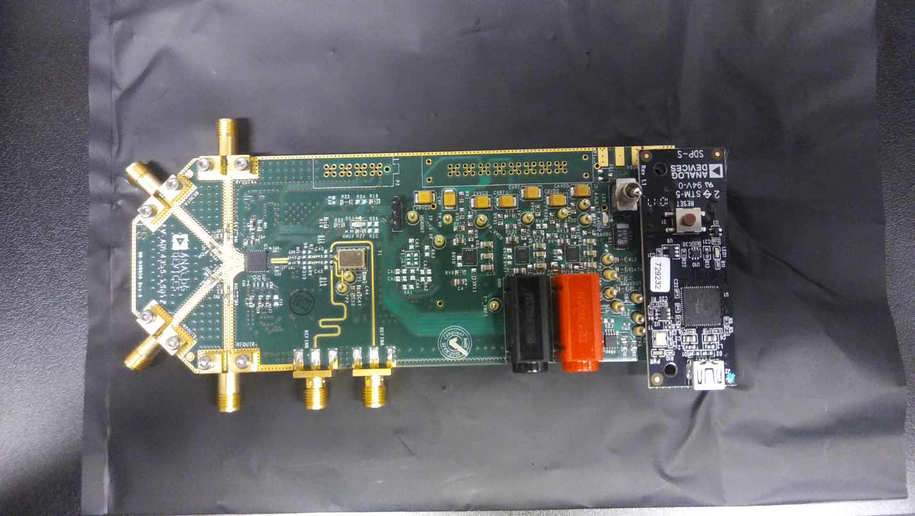

Figure 2 RF Synthesizer Board with USB Programmer Attached

## Programming Software

Programming software located at <http://www.analog.com/media/en/evaluation-boards-kits/evaluation-software/ADF4355_v1_2_3.zip>. This evaluation board must be connected to the SDP-S USB controller for standalone operation. The SDP-S is not required when using the Raspberry Pi.

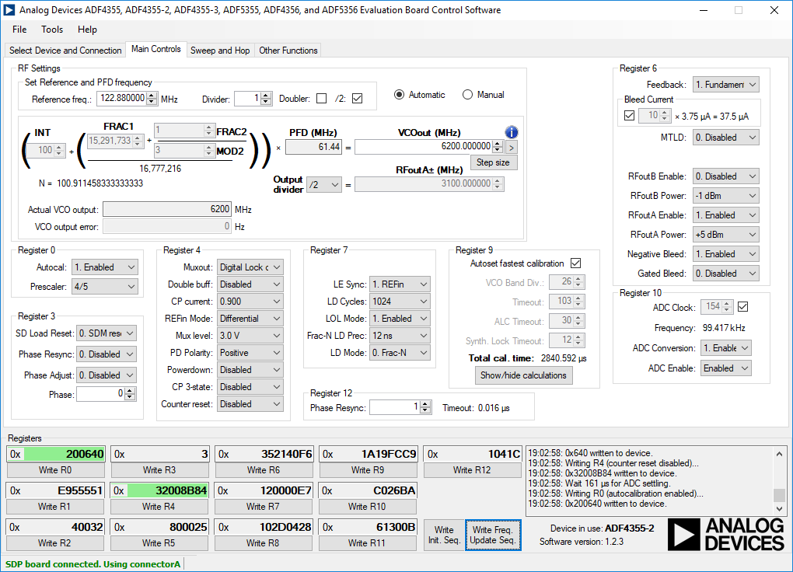

Figure 3 RF Synthesizer PC Programming Screen showing Frequency Reginsters and Programming Buttons

* The Initialization button must be pressed prior to programming the frequency
* The frequency button must be pressed after the initialization button to update frequency.
* Programming the frequency must take into account the limited range of the VCO on-board the PLL chip. Its range is 3.3 GHz to 6.8 GHz. Use the output divider to set the proper RFoutA frequency.

# Bring up of the Programmable Attenuator Board

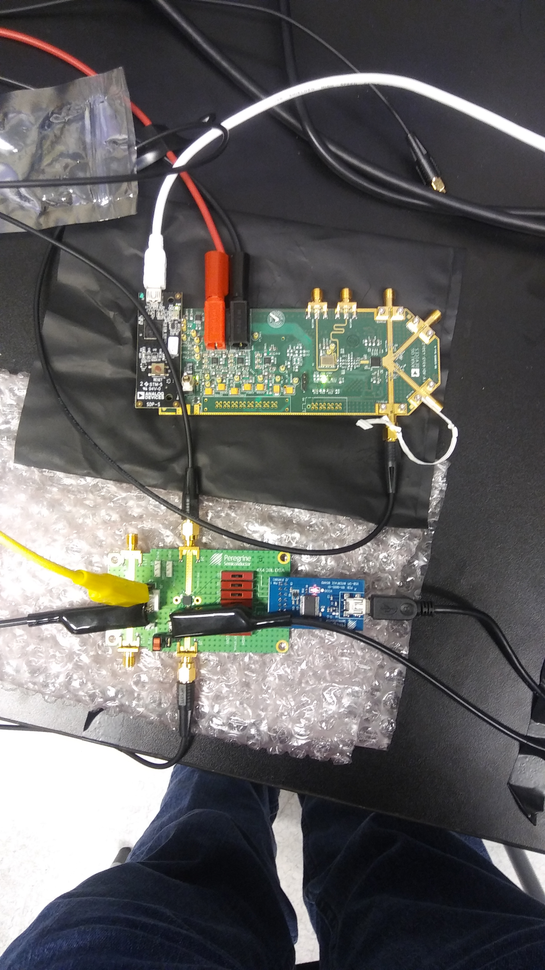

Figure 4 RF Synthesizer with Attenuator Board

The programming software for the Peregrine Semiconductor EK4312 evaluation board is at <http://www.psemi.com/products/digital-step-attenuators-dsa/pe4312>.

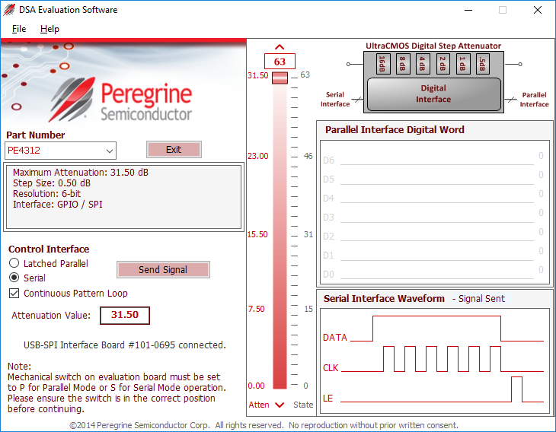

* Power supply for the Peregrine board requires 3.3V. The VDD and VDD_DIG connections on J9 should be connected using jumper JP3. The evaluation board manual makes mention of a negative supply of -3.3V on VSS but this can be set to GND for lab use.
* The VSS and GND connections should be shorted together using jumper JP1.
* The P/S switch J10 should be set to S for serial operation using the USB controller and SPI.

# Bring up of Raspberry Pi

The Raspberry Pi is shown below:

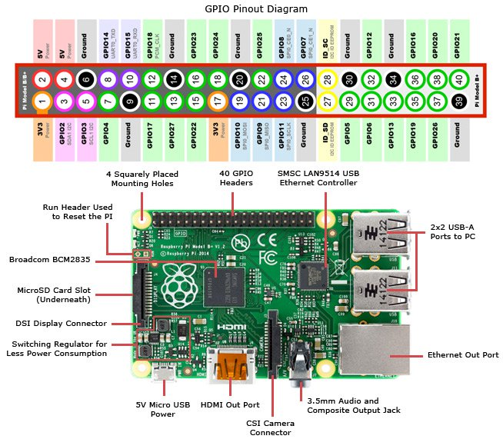

Figure 5 Raspberry Pi 3 with Pinout

* The Raspberry Pi 3 requires a new clean SD micro card
* Download Raspbian Stretch Lite from <https://raspberrypi.org/downloads/raspbian/>.
* Download Etcher from <http://etcher.io>.
* Unzip the Raspbian image (Etcher will not warn and does not unzip)
* Restore the Raspbian image to the SD card using Etcher
* Using local keyboard and mouse, log into the Raspberry Pi
  + User: pi
  + Password: raspberry
* Update runtime image using

sudo apt-get update  
sudo apt-get upgrade

* Enable SSH server  
   sudo raspi-config  
   Select Interfacing Options->SSH and enable

## Installation of SPI-Dev for Python

* Install python development:  
  sudo apt-get install python-dev
* Enable SPI  
  sudo raspi-config  
  Select Peripherals->SPI and enable
* Reboot
* Download spi-dev packages  
  wget clone <https://github.com/doceme/py-spidev/archive/master.zip>  
  unzip master.zip  
  cd py-spydev-master
* Build and install   
  python setup.py build  
  sudo python setup.py install

## Example Test Program

#!/usr/bin/python

###### Test program for SPI #####

import spidev

import time

spi = spidev.SpiDev()

spi.open(0,0)

spi.max_speed_hz = 7629

while True:

spi.xfer([0x1,0xff])

time.sleep(0.5)

spi.xfer([0x0, 0x0])

time.sleep(0.5)